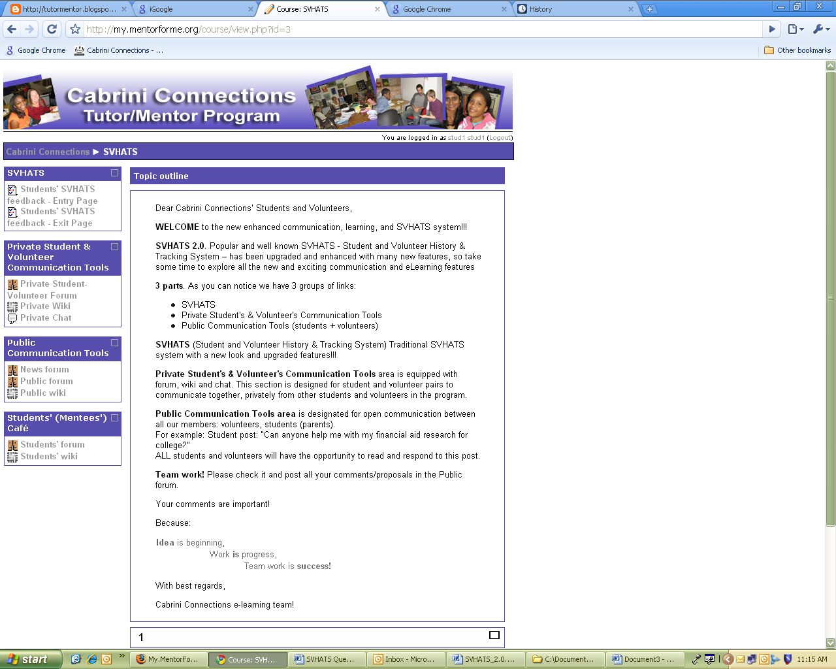
Students café is area designated just for students. It is mirror of the Mentors café: Students can use forum, chat and wiki while mentors can not come to Students’ Café.
Parents’ café is area where the parents can discuss about all the Cabrini Connections subjects.
Subscription to a forum
Members subscribed to a forum will receive copy of each post as an e-mail. However, for all the forums you can decide if you want or do not want be subscribed.
News forum.is designated specifically for very important news sent by Cabrini staff. Therefore you can not unsubscribe yourself from it.
How to subscribe or unsubscribe from a forum? You can (un)subscribe yourself from each forum simply by clicking on the Unsubscribe from this forum link in right up corner of the first forum screen.

Personal blog
Each Mentor for Me user can maintain blog. We recommend using a blog as a journal in which students and/or mentors will record details about subjects of their interest.

Interest/skills Inventory
Personal profile has numerous fields to input interests and skills. Therefore fill it as much as possible. If the field is not relevant to you (eg. working position for a student, or grade for a volunteer), you can leave it blank.
Linkable interests. All the interests you write in the interest box will be linked to all members that share the same interest. Therefore be cautious to spell your interests properly.

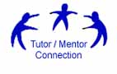

For more detils contact:
- e-mail: info@mentorforme.org
- URL: www.mentorforme.org
- Phone: (312) 492-9614

Cabrini Connections

SVHATS 2.0

Student Volunteer History And Tracking System
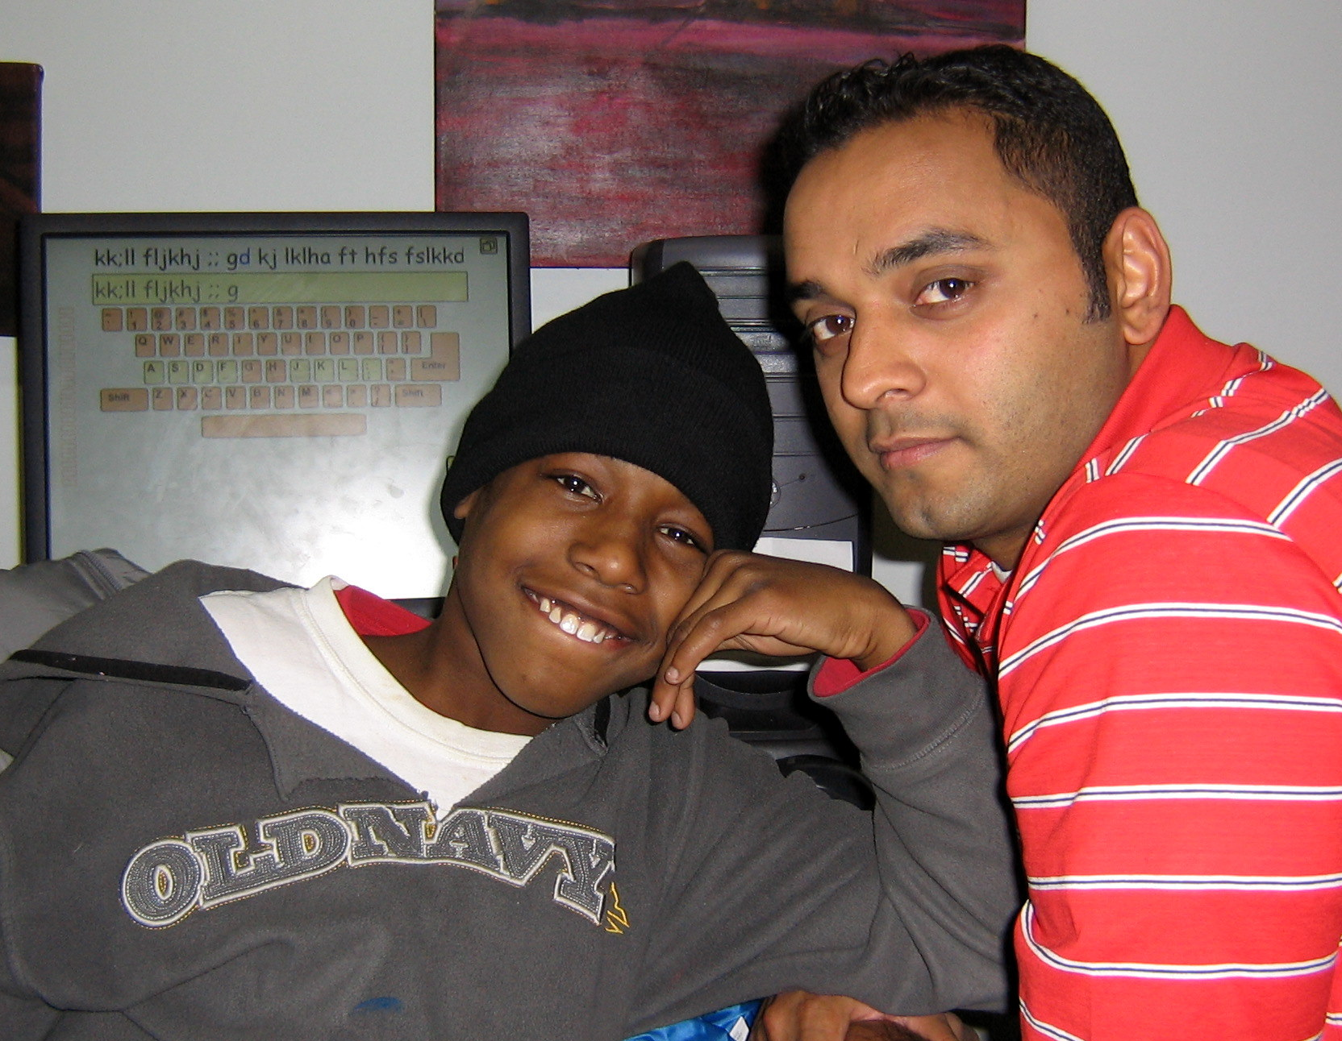
www.cabriniconnections.net
SVHATS is the Cabrini Connections on-line history of the journey of students and volunteers through the years they participate in this program. It has 3 main purposes:
Communication. SVHATS system is designed support online communication between students, volunteer-mentors, volunteer-coordinators, Cabrini staff and parents. It has multiple communication tools: forums, wikis, chats, messages and multiple group roles. Therefore mentor and student can have private forums, chat rooms, and a wiki. Also, the system can provide multiple rooms with different level of privacy. For example, rooms can be:
Just for mentors,
Just for students,
Just for parents,
Open – for everybody who is a part of the Cabrini Connections program…
New skills. SVHATS communications tools will not only enhance communications, but will build skills students and volunteers can apply in school and in 21st century jobs and careers.
Quality control. By documenting what you do, and responding to periodic surveys, we can show the impact Cabrini Connections has on keeping students and volunteers connected, helping students succeed in school, and helping students learn to use the internet for learning, collaboration and problem solving. If we demonstrate this effectively, we can attract more consistent funding.
Support the Quality. Since the feedback from students and volunteers is extremely important, everyone is expected to use this system and report their work and progress before, during or after each weekly mentoring session, or club activity.
Cabrini Connections will use this data to illustrate the impact our program has on students and to increase the quality of support Cabrini provide to students volunteers, and parents.
How to Log In?
You will receive a sheet with your SVHATS username and password on the first day of mentoring.
To begin using SVHATS:
Go to: www.my.mentorforme.org
Enter your username and password
Click Login
Click SVHATS link
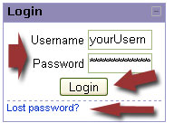
To Log a Session
Click on Entry or Exit in the Feedback menu
Type your comments
Click [Submit] button
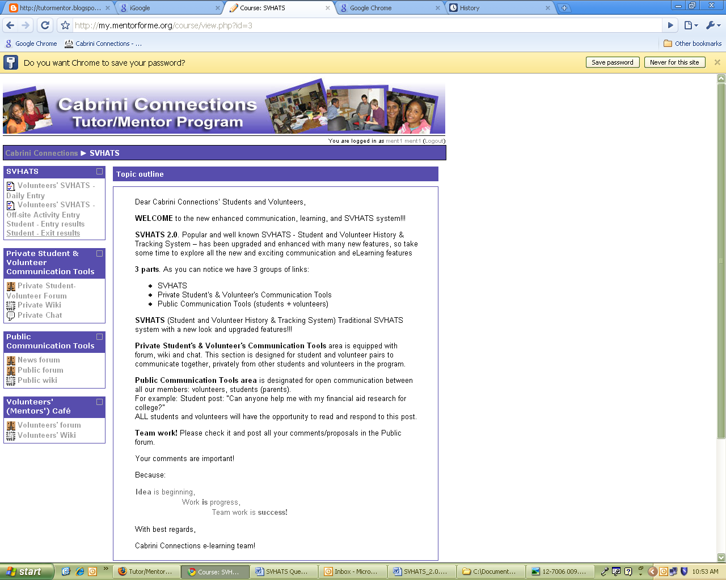 | Volinteers and students SVHATS menue

Lost password?
If you have lost your password, simply click the Lost password? link, type jour email address or your login name, and in a few minutes and e-mail with resetting password data will come to your e-mail address.
Features
Private Student's & Volunteer's Communication Tools area is equipped with forum, wiki and chat. Whatever you and your student/volunteer write there will stay private; other volunteers and students can not see it.
SVHATS (Student and Volunteer History & Tracking System) is equipped with 4 questionnaires: 2 for volunteers/mentors and 2 for students/mentees. Please use them regularly, so we can understand the best ways to accommodate both students and volunteers.
If you want to see your previous responses, please click on the [Your responses] button – just above this text.
If you want to see responses done by jour student/mentee, please check the students’ feedback.
Public Communication Tools area is designated for open communication between all our members: volunteers, students (parents, supporters…).
Volunteers’ café is area designated just for volunteers-mentors. Students can not use the forum or chat and can not add any content to the wiki.

